Generated dataset:

V = 15, k = 10, alpha = [0.75, 0.85], max_depth = [4, 6].

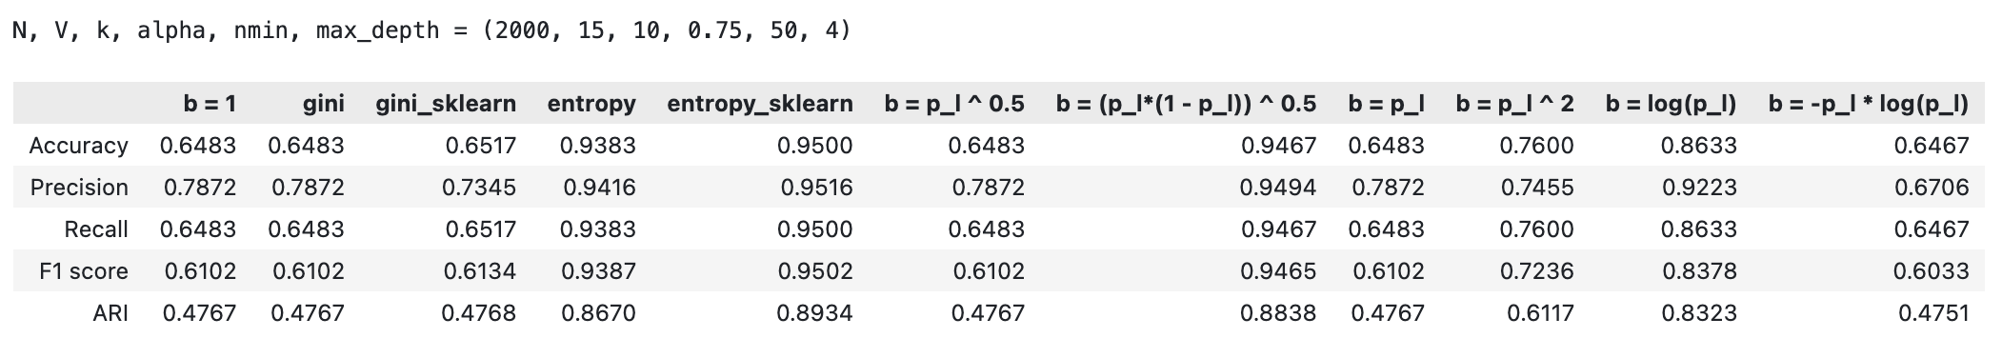

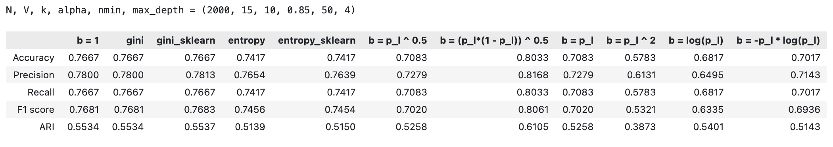

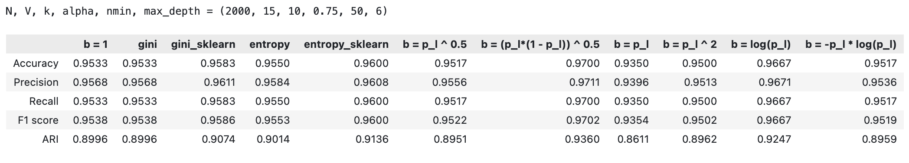

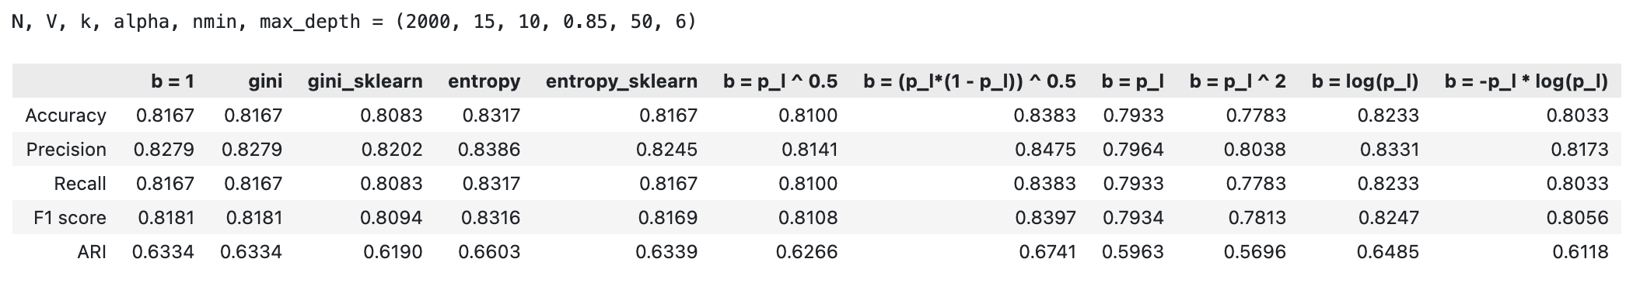

Generated dataset:

V = 15, k = 15, alpha = [0.75, 0.85], max_depth = [4, 6].

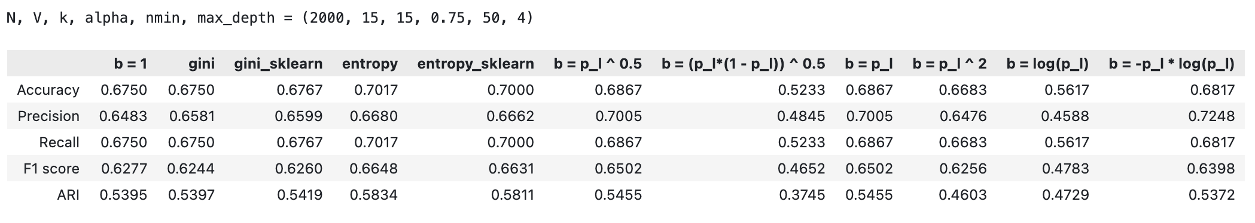

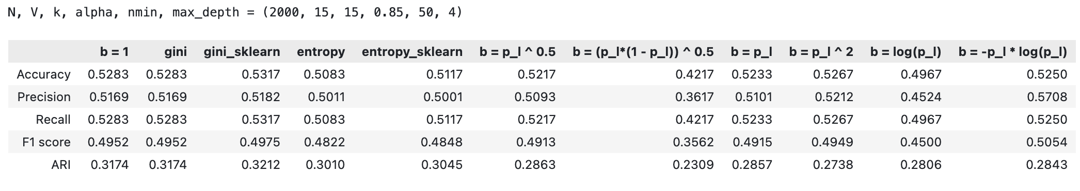

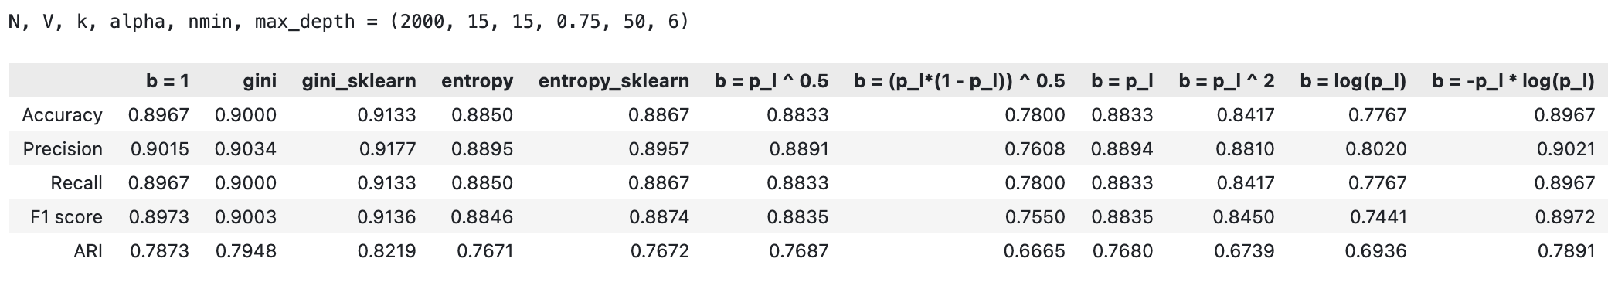

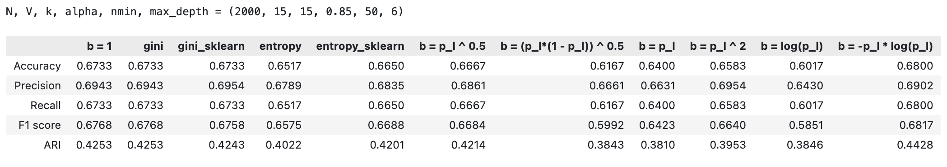

Sklearn datasets:

Iris:

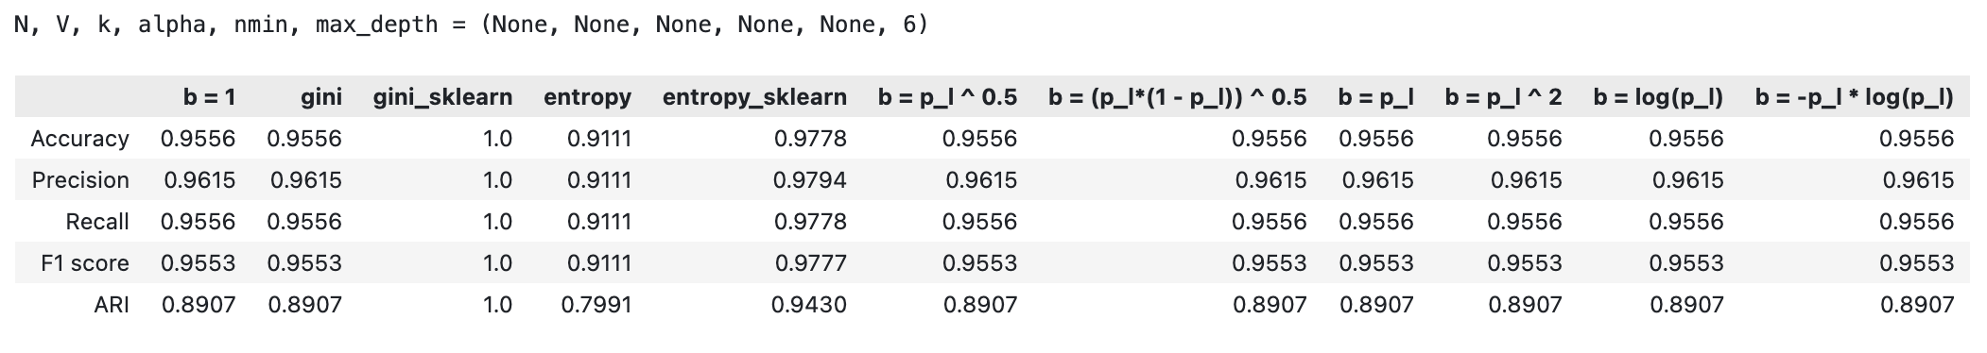

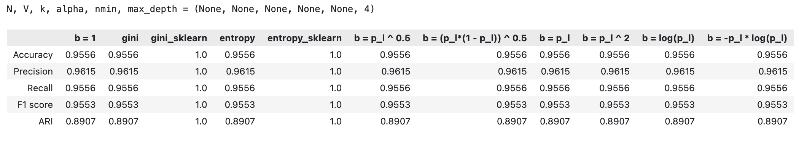

Wine:

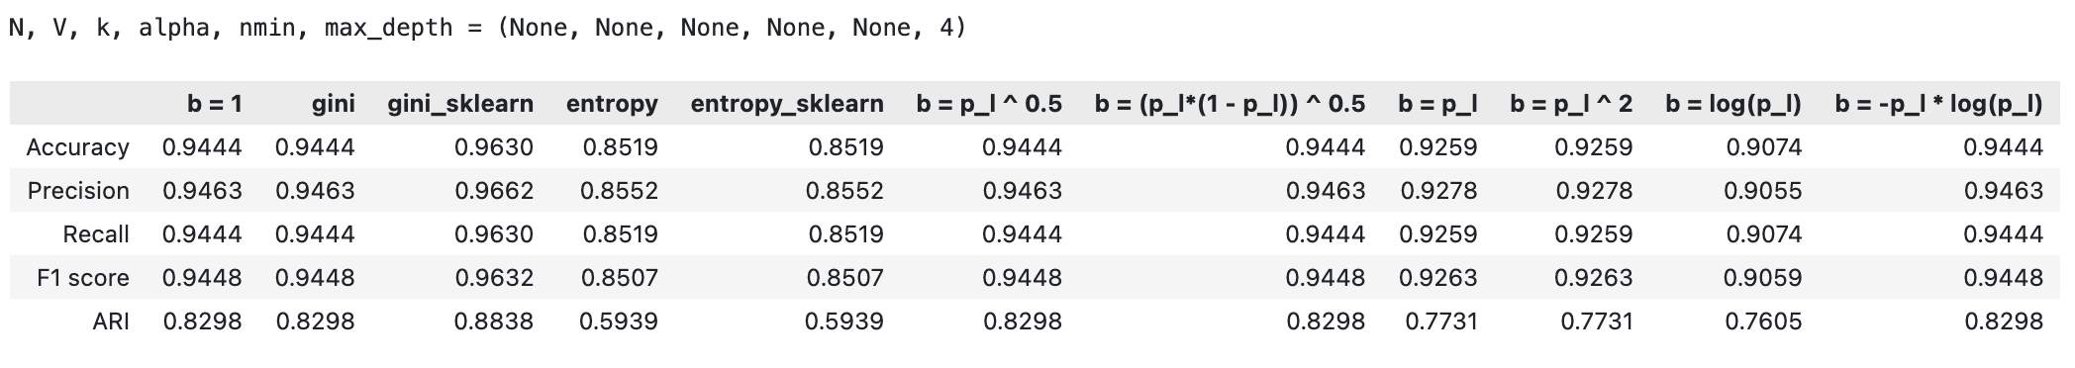

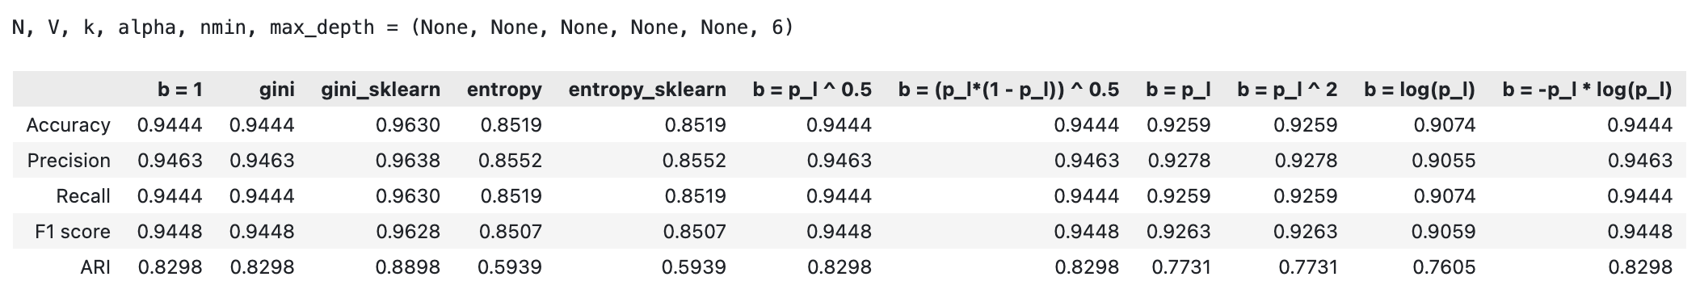Obesity: 